

“Bird King” by Thomas Dambo – Vashon Island, Washington

Vashon Island School District No. 402

2024-2025 BUDGET

*“Every student is Welcomed, Known, and*

*Treasured, and graduates confident and*

*competent to thrive in a future they imagine.”*

Approved/Adopted by the Board of Directors July 25, 2024

2024-2025 Budget

TABLE of CONTENTS

Introduction Pg. 4

Cover Letter / Executive Summary

Four-Year Budget Plan Summary

District Information Pg. 12

Board of Directors

District Administration

Schools & Principals

Organization Chart

Student Fee Schedule

24-25 School Calendar

Vashon Island Property Tax Rates

Budget Development Process Pg. 20

What is a Budget?

Budget Assumptions & Priorities

Budget Summary & Resolution Pg. 23

Summary of 2024-2025 Budgets

2024-2025 Budget Resolution No. 810

Staffing Budget Summary Pg. 27

Classified FTE Budget Comparison

Certified FTE Budget Comparison

Revenues to Support Operations

Enrollment Pg. 31

2024-2025 Summary of Estimated Enrollment - FTE

Historical & Projected Student Enrollment - FTE

Historical Off-Island (Commuter) Student Enrollment – FTE

Historical Running Start Student Enrollment - FTE

F-195 – OSPI/State of Washington – 2024-2025 Budget Pg. 34

10 - General Fund

20 - Capital Fund

30 - Debt Service Fund

40 - Associated Student Body Fund (ASB)

90 - Transportation Vehicle Fund

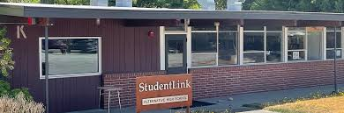

Vashon Island School District – ALE Programs



Introduction

Executive Summary

Dear School Board Members,

The Vashon Island School District 2024-2025 fiscal year budget is outlined below and throughout this document. The Superintendent and the Director of Business & Finance assume responsibility for data accuracy and completeness.

The development, review, and consideration of the 2024-2025 General Fund, Capital Fund, Debt Service Fund, Associated Student Body Fund (ASB), and Transportation Vehicle Fund Budgets were completed with a review of revenues and expenditures within the context of the District’s mission, goals, and financial policies. Starting in early 2024, the administration met with school administrators to discuss the staffing needs of each school for the 2024-2025 school year. In addition, multiple meetings were held with budget managers throughout the District, to include: school principals and their office managers, department heads and division/program managers so that all parties had ample input on each department/division’s budgetary needs.

We are pleased to publish and disseminate budget information to School Board members and to our community. We welcome the opportunity to present and discuss operational plans and related financial impacts with all parties. We believe that interaction among interested groups consistently leads to better operations and educational improvements for students in the Vashon Island School District.

Our goal in the presentation of the budget is to provide accurate and concise information to both the School Board and to our community about the District’s educational programs and services for the 2024-2025 fiscal year as it translates into a financial plan, the budget.

Goals and Themes

This budget reflects the allocation of revenues and expenditures to support educational programs and services as defined by the District’s Mission and through financial and operating policies. The budget is a balance among policy choices and values. It represents a balance between the educational needs of the students and the ability of the state and community to provide the necessary financial support.

Budget Process and Changes

The planning and preparation of the budget started in January with a budget calendar and input from the School Board. The School Board and District Administration discussed the student enrollment forecast for 2024-2025, with an estimate of 1,399 student FTEs (full time equivalents) for the coming fiscal (school) year. The enrollment forecast provides the assumptions on which building budgets are formulated and staff resources are determined.

*The chart below shows a comparison of the proposed expenditures for all funds for the current fiscal year vs. the projected fiscal year.*

|  |  |  |  |  |
| --- | --- | --- | --- | --- |
| **EXPENDITURE COMPARISON for ALL FUNDS** | | | | |
| **Fund** | **2023-2024**  **Budget** | **2023-2024**  **Budget** | **Change** | **Percent Change** |
| General | 27,271,491 | 27,974,629 | +703,138 | +2.51% |
| Capital | 12,650,000 | 1,995,008 | -10,654,992 | -84.23% |
| Debt Service | 3,809,600 | 3,525,100 | -284,500 | -7.47% |
| ASB | 259,933 | 343,125 | +83,192 | 32.1% |
| Transportation | 20,000 | 20,000 | 0 | 0 |

Analysis of Proposed Capital, Debt Service, Associated Student Body (ASB), and Transportation Funds Budgeted Expenditures

**Capital** –

**Debt Service** –

**ASB** –

**Transportation** –

Analysis of Proposed General Fund Budgeted Expenditures

The education of students is a labor-intensive enterprise, as reflected in the personnel salary and benefit costs of the District. The workforce of the District is determined by staffing policies and guidelines of the School Board on the basis of projected student enrollment, education and curricular requirements. Personnel costs are based on conditions of employment established by collective bargaining agreements (CBA’s) and District policies. For the 2024-2025 school year, salaries and benefits are budgeted to account for approximately 77.55% of the expenditures in the General Fund (GF), with MSOC’s (Material Supplies and Operating Costs) accounting for 22.45%. In comparison, for the 2023-2024 school year, salaries and benefits were budgeted to account for approximately 79% of the expenditures in the General Fund (GF), with MSOC’s (Material Supplies and Operating Costs) accounting for 21%. It must be noted that despite the McCleary decision, the State of Washington STILL provides only a portion of necessary funding for basic education and special education. It should be noted that state funding does not provide for facility construction or major maintenance. Lastly, almost one-third of the salaries and benefits are provided by local taxpayers through the Educational Programs & Operations Levy (EP&O), state and federal (grant) funding, and/or through local community fundraising.

|  |  |  |  |  |
| --- | --- | --- | --- | --- |
| **FOUR-YEAR BUDGET PLAN SUMMARY** | | | | |
| **Fund** | ***2023-2024***  ***Budget\**** | ***2024-2025***  ***Budget\**** | ***2025-2026***  ***Budget\**** | ***2026-2027***  ***Budget\**** |
| General | *27,974,679* | *27,952,550* | *28,136,750* |  |
| Capital | *1,995,008* | *1,995,008* | *1,995,008* |  |
| Debt Service | *3,525,100* | *3,688,400* | *20,709,225* |  |
| ASB | *343,125* | *351,000* | *355,000* |  |
| Transportation | *20,000* | *20,000* | *110,000* |  |

*\*Per RCW 28A.505.060 the State of Washington requires school districts to provide a four-year budget plan summary (estimate) for all funds.*

*The chart below shows a comparison of the proposed expenditures by Object code (an expenditure category) for the current fiscal year vs. the projected fiscal year.*

|  |  |  |  |  |
| --- | --- | --- | --- | --- |
| **GENERAL FUND EXPENDITURE COMPARISON by OBJECT** | | | | |
| **Object Code Description** | **2023-2024**  **Budget** | **2024-2025**  **Budget** | **+/-**  **Change** | **Percent Change** |
| *Salaries & Benefits* | | | | |
| Salaries-Certificated (2000) | 11,155,043 | 11,384,538 | +229,495 | +2.1% |
| Salaries–Classified (3000) | 4,629,290 | 4,843,777 | +214,487 | +4.6% |
| Benefits (4000) | 5,798,639 | 5,465,107 | -333,352 | -6.2% |
| **Subtotal** | **21,582,972** | **21,693,422** | **+110,450** | **+0.5%** |
| *MSOC – Materials, Supplies, & Operating Costs* | | | | |
| Supplies & Materials (5000) | 2,085,999* | 2,613,354 | +527,355 | +20.18% |
| Purchased Services (7000) | 3,466,630 | 3,527,853 | +61,223 | +1.73% |
| Travel (8000) | 80,890 | 85,000 | +4,110 | +4.38% |
| Capital (9000) | 20,000 | 20,000 | 0 | 0 |
| FieldTurf Reserves (GL 870) | 35,000* | 35,000* | 0 | 0 |
| **Subtotal** | 5,688,519 | 6,281,207 | +592,688 | +9.44% |
| **TOTAL** | **27,271,491** | **27,974,679** | **+703,148** | **+2.51%** |

*Budgeted in Supplies & Materials / Shown separately above

Comparing the 2023-2024 Expenditure Budget to the 2024-2025 Expenditure Budget above results in an overall estimated expenditure increase of +$703,138 or +2.51%. The main increase, as seen above, is MSOCs. The following page provides a chart with more detailed explanations for the changes in each Object category.

Vashon Island School District – Exchange Students from Costa Rica

|  |  |  |  |
| --- | --- | --- | --- |
| **OBJECT** | **DESCRIPTION** | **+/- CHANGE** | **EXPLANATION** |
| 2000 | Salaries – Certificated | +1% | **Increase** due to bargained salaries for  certificated staff and non-represented  certified staff |
| 3000 | Salaries - Classified | +4.6% | **Increase** due to bargained salaries for  classified staff and non-represented  classified staff |
| 4000 | Benefits | -6.2% | **Decrease** due to retirement contributions via the State of Washington |
| 5000 | Supplies & Materials | 20.18% | **Increase** due to inflation on goods and materials, such as insurance, utilities, supplies. Also, as is practice in budget, there is capacity built in to be able to accept unexpected revenues (such as an increase in enrollment or grants) |
| 7000 | Purchased Services | 1.73% | Increase due to the loss of grants that were paying for contracts |
| 8000 | Travel | 4.38% | **Increase** due to anticipated increase in ferry costs |
| 9000 | Capital | 0% | **No change** |

Vashon High School – District 4X400 Champs

2024-2025 Budgeted Annual Expense $27,974,629

Personnel Expenses Include: Salaries, L&I, FICA, Retirement, & Benefits – Medical/Dental/Vision

MSOC (Materials, Supplies, & Operating Costs) Expenses Include: School & Office Supplies, Purchased Services/Contracts, School Lunches/Commodities, Utilities, Maintenance & Grounds Supplies, Transportation, Rentals/Leases, Miscellaneous (NWRDC), Insurance, Travel, & Capital Projects/Equipment.

Financial support for District programs and services are substantially derived from local sources of revenue primarily from the Educational Programs and Operation (EP&O) Levy and the Capital & Technology (Cap/Tech) Levy, all paid for by local property taxes. In addition, the State legislature continues to mandate many programs, services, and reporting not funded by the State, thereby negatively impacting local resources as well; we know these as “unfunded mandates.”

***Revenue= 23.5% from Local 68.3% from the State / 8.2% from Federal/Other***

**Total Revenue = $27,974,629**

We appreciate the guidance and support provided by the School Board, staff, faculty, and the Vashon Island community for the development, implementation, and evaluation of the educational programs for students of the Vashon Island School District.

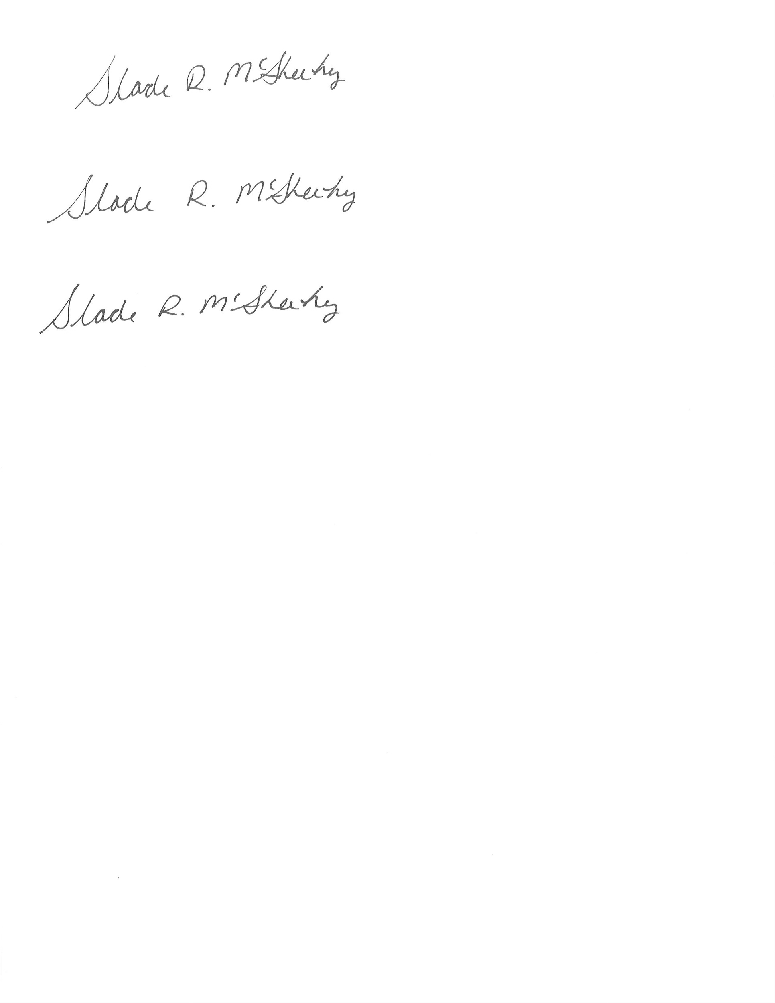

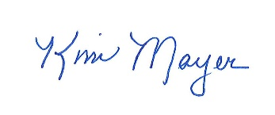

Dr. Slade McSheehy Kim Mayer

Superintendent Executive Director of Business & Operations



District Information

Board of Directors – “The School Board”

The School Board is made up of five volunteers who have been elected to serve four-year terms to guide and direct the District. As elected representatives, the Board is responsible for collecting input from the community. A school board’s main role is to set direction and establish goals for the District. Members of the School Board are responsible for governing, while the Superintendent and the administrative staff are responsible for managing. The Superintendent’s role is to implement and administer the direction set by the School Board.

Position / Term

Lucia Armenta #1 / 2023-2027

*Board Chair*

Kaycie Alanis #2 / 2023-2025

Martha Woodard #3 / 2023-2027

River Branch #4 / 2024-2025

Juniper Rogneby #5 / 2023-2027

*Board Vice Chair*

##### District Administration

Superintendent Dr. Slade McSheehy

(206) 463-8534

Director of Business & Finance Kim Mayer

(206) 463-8527

Director of Human Resources Amy Sassara

(206) 463-8529

Director of Student Services Kathryn Coleman (206) 463-8532

Director of Teaching & Learning Dr. Stephanie Spencer

(206) 463-8531

Director of Facilities TBD

(206) 463-8629

Director of Technology John Stanton

(206) 463-8633

Food Service Program Manager Cierra Hunziker

(206) 463-1104

##### 

##### District Administration

Schools & Principals / Directors

**Chautauqua Elementary School**

“Orcas”

9309 SW Cemetery Rd

Vashon, WA 98070

(206) 463-2882

Julie Kangas, Principal

Karen James, Assistant Principal

**McMurray Middle School**

“Mustangs”

9329 SW Cemetery Rd

Vashon, WA 98070

(206) 463-9168

Greg Allison, Principal

**Vashon Island High School**

“Pirates”

9600 SW 204th Street

Vashon, WA 98070

(206) 463-9171

John Erickson, Principal

Sabrina Kovacs, Assistant Principal

**Family Link & Student Link – ALE (Alternative Learning Experience)**

“Lynx”

9600 SW 204th Street

Vashon, WA 98070

(206) 463-8686

HEATHER ERICKSON, PROGRAM MANAGER

Vashon Island School District 2024-2025

Organization Chart

Chautauqua Elementary School – Music “Jam Session”

Vashon Island School District - Student Fee Schedule 2023-2024

VISD – Pride Month

Vashon Island school District – 2024-2025 Calendar

DRAFT Vashon Island Property Tax Rates 2024

Of the $2.28 **locally** assessed levy for schools, $0.88 goes towards the payment of the bond (Debt Service Fund), $1.06 is for the Educational Programs and Operations (EP&O) Levy and $0.34 is for the Capital and Technology (Cap/Tech) Levy.

Historical Actual Collections**

2017 2018 2019 2020 2021 2022 2023

|  |  |  |  |  |  |  |  |
| --- | --- | --- | --- | --- | --- | --- | --- |
|  | $4,175,294 | $4,341,056 | $3,934,392 | $3,910,235 | $3,899,393 | $3,994,600 | $4,446,253 |
|  | $925,317 | $940,495 | $961,765 | $982,249 | $1,484,265 | $1,487,628 | $1,487,374 |
|  | $3,728,754 | $3,850,666 | $3,996,507 | $4,129,341 | $3,989,540 | $3,971,264 | $4,115,978 |

*Note: The rates for 2023 are**based on current available data (estimates) via the King County Assessor’s Office.*

*\*Levy rates are expressed in dollars per $1,000.00 of assessed valuation (AV)*

*\*\*Collection (dollar) figures are based on calendar year, NOT school year and may include past due collections*



Budget Development Process

What is a Budget?

* It an instrument that sets forth an annual financial plan for the District, which reflects District and community goals
* Establishes maximum amounts the District can spend for each fund without a budget adjustment. There are five (5) funds: **General, Associated Student Body (ASB), Capital, Debt Service, and Transportation**
* Provides a means of measuring and guiding performance by comparing planned expenditures and staffing levels against actual expenditures.
* Must be balanced
* Covers the fiscal year, from September 1st to August 31st of the following calendar year
* Must be formally approved/adopted by the School Board each year, and a copy submitted to the local educational service district (Puget Sound Educational Service District - PSESD) and the State Superintendent of Public Instruction (OSPI) for review and approval

# The Accounting System

The accounting system is organized and operated on a “fund” basis of accounting. The only funds school districts may use are those established by law. The Vashon Island School District uses the following five (5) funds:

1. **General Fund** - used for all instructional and regular operations of the District.
2. **Capital Projects Fund** - used for the purchase of land, the construction and equipping of new facilities, and facility renovations.
3. **Debt Service Fund** - covers the principal and interest payments on outstanding construction bonds.
4. **Associated Student Body Fund** **(ASB)** - used for all student activities, such as clubs, student government, and athletic programs. The acronym to remember what the ASB fund can be used for is “CARS,” which equals *Cultural, Athletic, Recreational, and Social*.
5. **Transportation Vehicle Fund** - used exclusively for the purchase and repair of equipment approved for pupil transportation, or in common parlance = “big yellow buses.”

Note: *By law, funds in the Debt Service Fund, the Associated Student Body (ASB) Fund and the Transportation Vehicle Fund cannot be transferred to the General Fund nor used for instructional or regular operations of the District.*

Budget Assumptions and Priorities

* Per District Policy 6000, it is the goal of the District to maintain a fund balance of six and one-half percent (6.5%) of the current fiscal year budgeted expenditures with a minimum unreserved fund balance of no less than five percent (5%). The unreserved ending fund balance will be preserved as an emergency fund.
* Carryover will be budgeted (for capacity) from unexpended 2023-2024 revenues collected for grants (if allowable), donations, and student fees/fines.
* Enrollment will be budgeted at 98% of the value of the cohort (class) projection, or at 1,399 FTE for 2024-2025.
* An amount of at least $85.00 per student for MSOC (materials, supplies, and operating costs) will be allocated to the buildings and may be adjusted as enrollment changes or as levy legislation changes.
* Dollars will be specifically allocated for professional learning communities, curriculum materials and professional development for staff.
* When the goal of 6.5% committed (unreserved) fund balance is reached additional revenues will be committed, if available, for the following liabilities: (1) Unemployment Insurance, (2) Benefit Liability *(sick leave/annual leave and retirement cash out)* and Curriculum/Professional Development Reserve.
* Student fee schedules will be included as part of the budget adoption proposal.
* Special Education staffing will be maintained, enhanced, or reduced based on student need and enrollment at each building/program.
* Grant programs will be budgeted to operate within grant revenue awards less the deduction for allowed state or federal indirect administrative costs.
* We will prioritize maintenance to protect District assets.



Budget Summary & Resolution

Summary of 2024-2025 Budgets

|  |  |  |  |  |  |  |
| --- | --- | --- | --- | --- | --- | --- |
| **FUND** | **YEAR** | **BEGINNING BALANCE** | **REVENUES** | **EXPENDITURES** | **OPERATING**  **TRANSFERS** | **ENDING FUND**  **BALANCE** |
| **General** | **23-24** | **$1,523,333** | *27,271,491* | *$27,271,491* | *$1,650,000* | *1,310,059* |
| **24-25** | *1,310,059* | *27,974,629* | *27,974,679* | *$1,650,000* | *1,525,613* |
|  | | | | | | |
| **Capital** | **23-24** | **820,450** | *1,529,395* | *1,930,000* | *1,630,000* | *$419,835* |
| **24-25** | *419,835* | *1,350,324* | *1,540,000* | *1,650,000* | *$230,159* |
|  | | | | | | |
| **Debt Service** | **23-24** | **$13,946,742** | *$5,267,788* | *$3,558,300* | *$0* | *$14,146,742* |
| **24-25** | *$14,146,742* | *$4,700,416* | *$3,525,100* | *$0* | *$15,321,788* |
|  | | | | | | |
| **ASB** | **23-24** | **$253,854** | *$254,600* | *$260,783* | *$0* | *$231,932* |
| **24-25** | *$231,932* | *$377,120* | *$343,125* | *$0* | *$265,927* |
|  | | | | | | |
| **Transportation** | **23-24** | **$64,498** | *$21,000* | *$20,000* | *$0* | *$59,642* |
| **24-25** | *$59,642* | *$19,700* | *$20,000* | *$0* | *$59,342* |

*23-24 Beginning Balance (in bold) is actual / italicized numbers are estimates

The “ending Balance” is also referred to as the District’s “fund balance” or “operational reserves” which consists of several types of accounts; **(1)** **Restricted, (2) Committed, (3) Assigned,** and **(4) Unassigned**.

1. **Restricted** accounts are for specific purposes imposed externally by creditors, grantors, contributors or imposed by law through constitutional provisions or legislation; **for VISD, this is where our carryover resides.**
2. **Committed** accounts can only be used for specific purposes or by formal action (e.g. resolution or board policy). This cannot be changed without a similar action on the part of the Board; **for VISD, this is where our FieldTurf Reserve resides**.
3. **Assigned** accounts represent amounts that are constrained by the school district’s intent to be used for a specific purpose, but are neither restricted nor committed; **for VISD, this is where our Unemployment Liability Reserve resides**. Authority for making these assignments rests with administration of the District.
4. **Unassigned** accounts are the residual fund balance designation for the General Fund – Fund Balance; **for VISD, this is where our fund balance resides.**

VASHON ISLAND SCHOOL DISTRICT No.402

**RESOLUTION No. 810**

**WHEREAS,** WAC 392-123-054 requires that the Board of Directors of every school district meet for the purpose of fixing and adopting the budget of the District for the ensuing fiscal year. Pursuant to RCW 28A.505.040, the District has completed the budget for the 2024-2025 fiscal year. The 2024-2025 budget provides a complete financial plan of the District for the coming fiscal year, a summary of the four-year budget plan, and a four-year enrollment projection.

**WHEREAS,** a public notice was published announcing that on July 25, 2024, the Board of Directors of Vashon Island School District No. 402, King County, Washington, would meet in a public meeting for the purpose of fixing and adopting the 2024-2025 budget of the District.

**WHEREAS,** interest earnings from investments in the Capital Projects Fund and the Debt Service Fund not required for immediate Capital Projects Fund and Debt Service Fund eligible necessities of the District may inure to the benefit of the General Fund to be expended for instructional supplies, equipment or capital outlay purposes per RCW 28A.320.320.

**WHEREAS,** on February 13th, 2024, the voters of the Vashon Island School District No. 402 of King County, Washington passed a four year (2025-2028) Capital & Technology (Cap/Tech) Maintenance Levy in the Capital Projects Fund for a total of $7,800,000 with the 2025 tax year collection in the amount of $1,950,000, with the 2026 tax year collection in the amount of $1,950,000, with the 2027 tax year collection in the amount of $1,950,000, with the 2028 tax year collection in the amount of $1,950,000, and;

**WHEREAS,** RCW 28A.320.330 (2) (f) requires a board resolution to transfer monies from the Capital Projects Fund to the General Fund for costs associated with the application and modernization of technology systems for operations and instruction, and;

**WHEREAS,** RCW 28A.320.330 (2) (g) requires a board resolution to transfer monies from the Capital Projects Fund to the General Fund for costs associated with major equipment repair, painting of facilities, and other major preventative maintenance purposes.

**WHEREAS,** the Accounting Manual for Public School Districts in the State of Washington requires “Committed” fund balance accounts monies to be established by a formal action such as this resolution.

**THEREFORE,** **BE IT RESOLVED** the Board of Directors of Vashon Island School District No. 402, King County, Washington, has determined that the final appropriation level of expenditures for each fund in 2024-2025 will be as follows:

|  |  |
| --- | --- |
|  | **APPROPRIATION LEVEL** |
| A. General Fund | $27,974,679 |
| B. Transportation Vehicle Fund | $ 20,000 |
| C. Capital Projects Fund | $ 1,995,008 |
| D. Debt Service Fund | $ 3,525,100 |
| E. Associated Student Body Fund | $ 343,125 |

**BE IT FURTHER RESOLVED** by the Board of Directors that investment earnings in the Capital Projects Fund and the Debt Service Fund related to the capital levy are not required for immediate Capital Projects Fund and Debt Service Fund eligible necessities of the District and may inure to the benefit of the General Fund to be expended for instructional supplies, equipment or capital outlay per RCW 28A.320.320.

**BE IT FURTHER RESOLVED** by the Board of Directors that monies from the Capital Projects Fund Technology and Capital Maintenance Levy (Cap/Tech Levy) are authorized to be transferred to the General Fund for costs associated with the application and modernization of technology systems for operations and instruction and for costs associated with major equipment repair, painting of facilities, and other preventative maintenance purposes.

**BE IT FURTHER RESOLVED** by the Board of Directors that monies in the Fund Balance are hereby “Committed” if available in the amount of $1,309,309 for the goal of 6.5%, while maintaining a 5% Minimum Fund Balance, and $26,500 for Carryover; if available, additional reserves will be “Committed” for (1) Unemployment Insurance and for (2) Benefit Liability.

**BE IT FURTHER RESOLVED** by the Board of Directors that on April 25, 2017 the electors of Vashon Island approved Proposition #1 for the issuance of general obligation bonds in the aggregate principal amount not to exceed $9,997,500 to finance certain capital improvements; the District will set aside and maintain in a reserve account $35,000, for a total of fifteen (15) consecutive years, from each the General Fund and the Technology & Facilities Capital Projects Levy (Cap/Tech Levy) to replace the all-weather turf surface at the end of its life, for a total estimated ending amount of $1,050,000.

**APPROVED** by the Board of Directors of Vashon Island School District No. 402, King County, Washington, in a meeting thereof held on the 25th day of July 2024. The Board hereby adopts the 2024-2025 Budget, to include: all salaries, benefits, positions, personnel, projects, purchases, the four-year budget plan summary, and the four-year enrollment projection as so finally determined.

ATTEST: _____________________________ ______________________________

Secretary - Board of Directors Director – Board Chair

_____________________________ ______________________________

Director – Board Vice Chair Director

_______________________________ ______________________________

Director Director



STAFFING Budget Summary

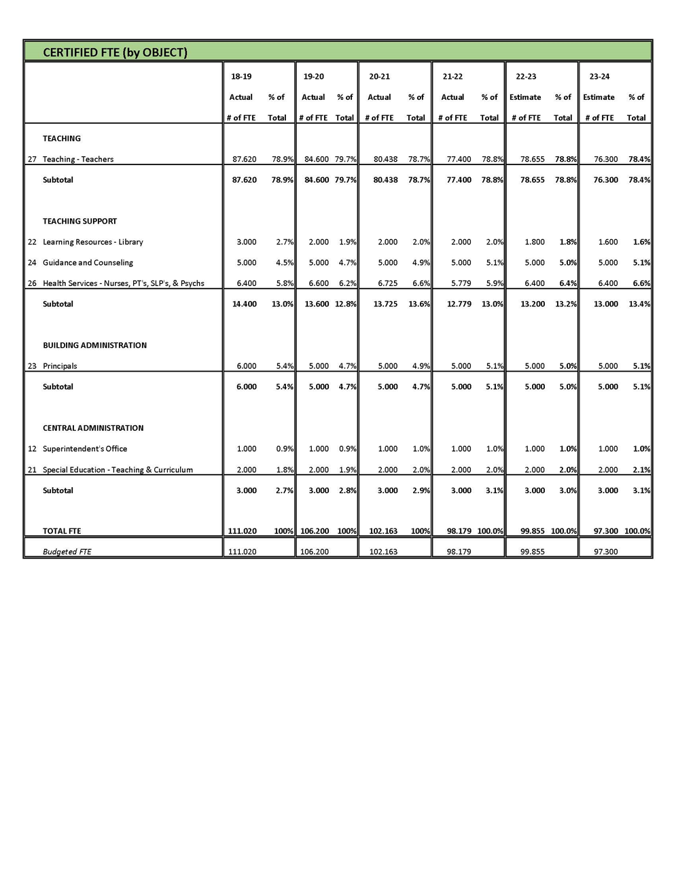

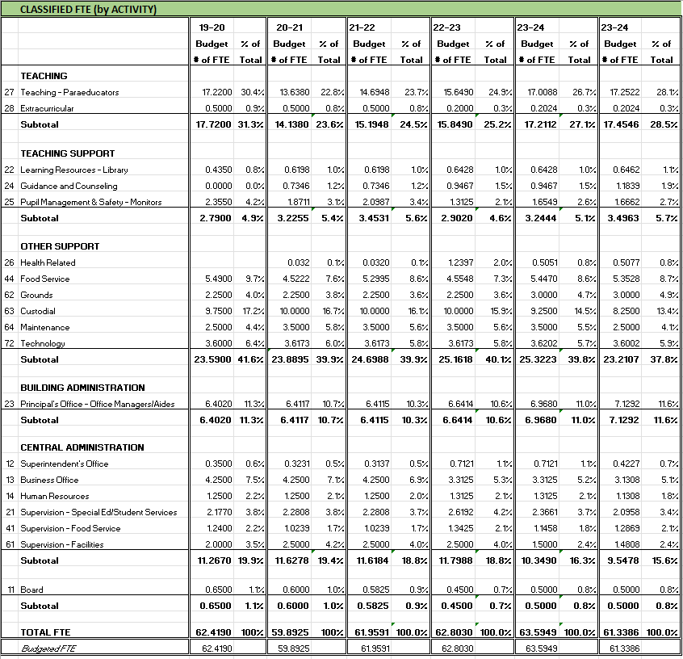

Revenues to Support Operations

Programs and services included in the General Fund budget are supported by local, state, and federal sources of revenue. A comparison of revenue sources to support operations for the current (2023-2024) and proposed (2024-2025) General Fund budgets are shown below.

|  |  |  |  |
| --- | --- | --- | --- |
| **REVENUE SOURCE** | **2023-2024 BUDGET** | **2024-2025 BUDGET** | **% CHANGE** |
| Local Taxes | 4,144,038 | 4,354,673 | +5.08% |
| Local Support, Non-Tax | 2,456,265 | 2,222,005 | -9.53% |
| State General Purpose | 14,583,439 | 14,966,968 | +2.63% |
| State Special Purpose (Special Ed) | 3,620,599 | 4,140,639 | +14.36% |
| Federal Special Purpose | 2,172,150 | 2,015,394 | -7.21% |
| Revenue - Other Entities | 295,000 | 275,000 | -6.77% |
| **Total Revenue** | **27,271,491** | **27,974,679** | **+2.51%** |

**Local Revenue - $6,576,628 or 23.5% of budgeted revenues**: consists of revenues from “Local Taxes” - local property taxes - EP&O Levy, state timber tax and “Local Support, Non-Tax” - donations (Schools Foundation/PTSA), student/sports fees, Cap/Tech Levy, food service meal purchases, summer school, tuition for preschool, state timber revenue, rent/leases, and investment earnings.

**State Revenue - $19,107,607 or 68.3 % of budgeted revenues**: consists of revenue from “apportionment” for Basic Education and Special Education and grants for Special Education (SPED), Highly Capable, Early Childhood Education and Assistance Program (ECEAP), and funding for Food Service, and Transportation.

**Federal & Other Revenue - $2,290,394 or 8.2% of budgeted revenues**: consists of revenue for grants such as the Learning Assistance Program (LAP), ESSER, Disadvantaged - Title I, Quality Schools – Title II, Limited English Proficiency – Title III, Individuals with Disabilities Education Act (IDEA), Student Support & Academic Enrichment - Title IV, Safety Net for Special Education, Perkins Grant for Career Technical Education (CTE), Bilingual, and federal timber tax, Commons Agreement w/ the Vashon Park District, and SBIRT Grant ($220k) and capacity ($1MM).



Enrollment

2024-2025 Summary of Projected Enrollment - FTE

|  |  |  |  |  |  |  |  |
| --- | --- | --- | --- | --- | --- | --- | --- |
| **GRADE** |  | **CES** | **McM** | **VHS** | **FAMILY LINK** | **STUDENT LINK** | **SUBTOTAL** |
| K |  | 67 |  |  | 3 |  | 70 |
| 1 |  | 52 |  |  | 6 |  | 58 |
| 2 |  | 80 |  |  | 10 |  | 90 |
| 3 |  | 67 |  |  | 4 |  | 71 |
| 4 |  | 74 |  |  | 6 |  | 80 |
| 5 |  | 96 |  |  | 13 |  | 109 |
| 6 |  |  | 108 |  | 8 |  | 116 |
| 7 |  |  | 120 |  | 8 |  | 128 |
| 8 |  |  | 112 |  | 7 |  | 119 |
| 9 |  |  |  | 140 |  | 7 | 147 |
| 10 |  |  |  | 140 |  | 14 | 154 |
| 11 |  |  |  | 93 |  | 9 | 102 |
| 12 |  |  |  | 134 |  | 21 | 155 |
| **TOTAL** |  | **436** | **340** | **507** | **65** | **51** | **1399** |

Historical & Projected Student Enrollment - FTE

|  |  |  |  |
| --- | --- | --- | --- |
| **YEAR** | **YEAR-END AVERAGE** | **INCREASE/DECREASE** | **% +/-** |
| 2008-2009 | 1456 | -45 | -3%% |
| 2009-2010 | 1451 | -5 | -.34% |
| 2010-2011 | 1452 | +2 | +.11% |
| 2011-2012 | 1446 | -7 | -.41% |
| 2012-2013 | 1418 | -28 | -1.94% |
| 2013-2014 | 1456 | +38 | +2.67% |
| 2014-2015 | 1463 | +7 | +.48% |
| 2015-2016 | 1463 | 0 | 0% |
| 2016-2017 | 1513 | +50 | +3.41% |
| 2017-2018 | 1509 | -4 | -2.6% |
| 2018-2019 | 1469 | -40 | -2.6% |
| 2019-2020 | 1461 | -8 | -.05% |
| 2020-2021 | 1421 | -40 | -2.7% |
| 2021-2022 | 1448 | +33 | +2.4% |
| 2022-2023 | 1430 | +15 | +1.06% |
| *2023-2024\** | 1438 | +8 | +.56% |
| *2024-2025\*\** | *1399* | *-39* | *-2.8%* |
| *2025-2026\*\** | *1399* | *0* | *0* |
| *2026-2027\*\** | *1399* | *0* | *0* |
| *2027-2028\*\** | *1399* | *0* | *0* |

\**Current Enrollment / \*\**Projection as required per RCW 28A.505.06

Historical Off-Island (Commuter) Student Enrollment - FTE

|  |  |  |  |  |  |
| --- | --- | --- | --- | --- | --- |
| **YEAR** | **CHAUTAUQUA**  **ELEMENTARY** | **McMURRAY**  **MIDDLE SCHOOL** | **VASHON HIGH SCHOOL** | **TOTAL** | **% of TOTAL ENROLLMENT** |
| 2008-2009 | 0 | 54 | 76 | 130 | 8.9% |
| 2009-2010 | 0 | 40 | 78 | 118 | 8.1% |
| 2010-2011 | 6 | 62 | 89 | 157 | 10.8% |
| 2011-2012 | 15 | 84 | 94 | 193 | 13.3% |
| 2012-2013 | 16 | 83 | 88 | 187 | 13.1% |
| 2013-2014 | 18 | 91 | 98 | 207 | 14.2% |
| 2014-2015 | 14 | 93 | 116 | 223 | 15.2% |
| 2015-2016 | 21 | 103 | 133 | 257 | 17.5% |
| 2016-2017 | 16 | 99 | 150 | 265 | 17.4% |
| 2017-2018 | 28 | 88 | 127 | 243 | 16.1% |
| 2018-2019 | 33 | 84 | 122 | 239 | 16.2% |
| 2019-2020 | 31 | 94 | 121 | 246 | 16.8% |
| 2020-2021 | 38 | 81 | 135 | 254 | 17.9% |
| 2021-2022 | 34 | 92 | 136 | 262 | 18.1% |
| 2022-2023 |  |  |  | 245 | 16.9 |
| *2023-2024\** | *23* | *91* | *143* | *257* | *18.3%* |

\**Current Enrollment*

Historical Running Start Student Enrollment - FTE

|  |  |  |  |
| --- | --- | --- | --- |
| **YEAR** | **YEAR-END AVERAGE ENROLLMENT** | **INCREASE/DECREASE** | **% +/-** |
| 2008-2009 | 29.11 | +12.3 | 73.2% |
| 2009-2010 | 26-02 | -3.09 | -10.6% |
| 2010-2011 | 31.95 | +5.93 | +22.7% |
| 2011-2012 | 26.13 | -5.82 | -18.2% |
| 2012-2013 | 25.68 | -.45 | -1.7% |
| 2013-2014 | 31.19 | +5.51 | +21.4% |
| 2014-2015 | 36.25 | +5.06 | +16.2% |
| 2015-2016 | 51.74 | +15.49 | +42.7% |
| 2016-2017 | 62.57 | +10.83 | +20.9% |
| 2017-2018 | 57.21 | -5.36 | -8.56% |
| 2018-2019 | 45.73 | -11.48 | -20.06% |
| 2019-2020 | 39.25 | -6.48 | -14.2% |
| 2020-2021 | 42.99 | +3.74 | +9.5% |
| 2021-2022 | 30.00 | -12.99 | -30.2% |
| 2022-2023 | 21.85 | -8.15 | -37.3% |
| *2023-2024* | *22.42* | *+.57* | *+2.6%* |

*\*Current Enrollment*



F-195